Computer Networks
- An interconnected collection of autonomous (independent) computers.

Examples: NJIT, AOL, AT&T, Internet……

- WHY DO WE NEED NETWORKS ?
➔ Goals ?
- Resource Sharing
- High Reliability
- Saving Money (How ?)
- Scalability (Demand VS Capacity)
- Powerful Communication Medium

➔ Applications ?
- Access to Remote Applications
- E-Mail
- Video Conferencing
- Video on Demand
- Entertainment
- Database
- E-Commerce
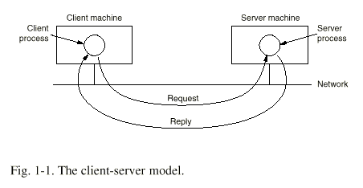

- In this model, communication takes the form of a request message from the client to the server, asking for data or work to be done. Server does the requested task and returns a reply.
- Usually there are many clients using a lot less number of servers.
- Security: Is this system secure or not ? (in regards to data exchange)
Network Hardware
- Two main types of Transmissions:
- Broadcast Networks
- Point-To-Point Networks

- Broadcast Networks: Single communication channel that is shared by all the machines on the network. Messages sent by any of the machines are received by all the stations in the network. Upon receiving the packets, each of the stations checks the @ field inside the packets and if it's intended for itself, it processes the request, otherwise ignores it !

- Multicasting VS Broadcasting:
- Which one is harder to do ?
- Can we broadcast on the internet ?
- Is Pay-Per-View broadcast or multicast ?

- Point-to-Point: networks consist of many connections between individual pairs of computers (multiple paths are possible).

➔ In general, smaller networks use broadcast technology as larger networks use PTP technology.

- What is the Internet ?
- Who "owns" it ?
- When did it start ?
LAN (LOCAL AREA NETWORKS)
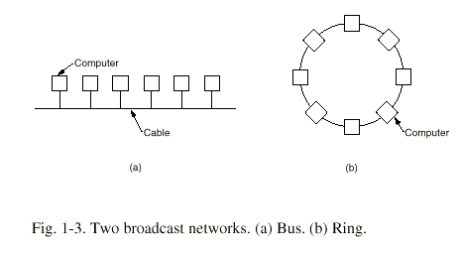

- LANs are restricted in size, so the worse-case transmission time is bounded and known in advance.
- It simplifies network management
- Types: 10-100 Mbps or Faster
- Ethernet (802.3 - IEEE) - Bus based broadcast network of up to 100 Mbps.
- Ring Network (token ring - 802.5 IEEE) Speeds: 4-16 Mbps - Only station that has the token can transmit.
MAN (METROPOLITAN AREA NETWORK)
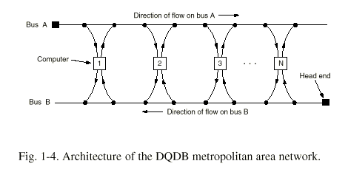

- MAN is a bigger version of LAN and uses similar technology.
- MAN can support both DATA & VOICE (Cable TV, etc.)
- DQDB is the standard (Distributed Queue Dual Bus) - 802.6 IEEE

➔ Traffic intended for computer at the Right side of senders, uses BUS A, all the other traffic BUS B.

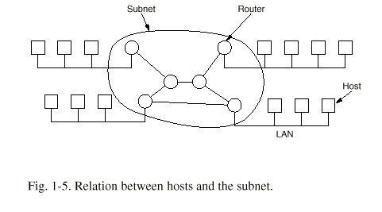
WAN (WIDE AREA NETWORK)

- HOSTS = User Machines - connected by a subunet that has the job to carry messages from Host to Host.
- In WANs, subnet has → a) Transmission Elements b) Switching Elements.
- Circuits, Channels, Trunks
- Specialized computers used to connect two or more transmission lines.
- Packets that are sent from one router to another are received and stored by intermediate routers until lines are free.

➔ Point-to-Point, or Packet-Switched Technology.

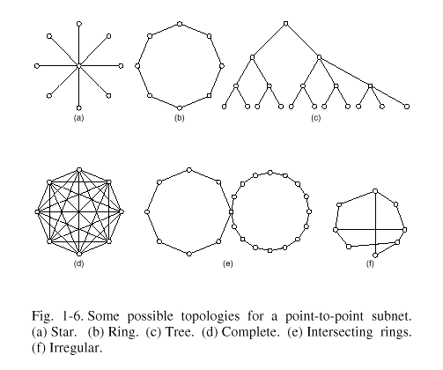
WIRELESS NETWORKS
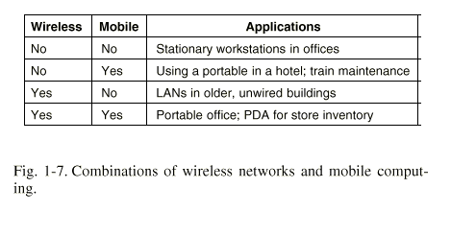

- Where are they used ?
- Portable office.
- Fleet of trucks, taxis, buses, etc.
- Rescue units, disaster areas, etc.
- Military & Security forces.

- Not all wireless equipment is portable (see above table)

- Wireless LANs are easy to install but have disadvantages:
- Capacity 1-2 Mbps → SLOW !!!
- High Error rates → Transmissions from computers can interfere.

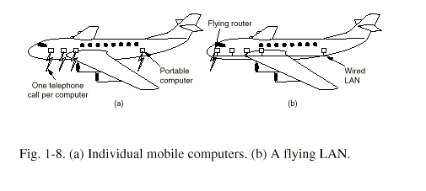
OSI (OPEN SYSTEMS INTERCONNECTION)

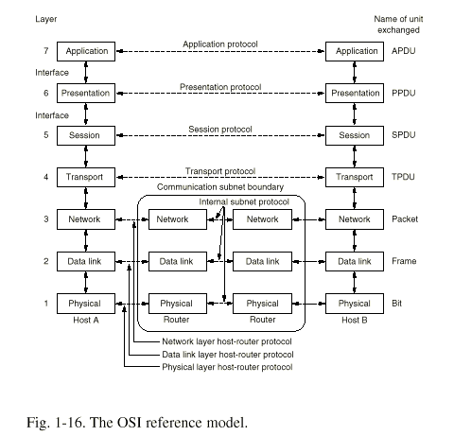
LAYERS (OPEN SYSTEMS INTERCONNECTION)

- Physical Layer: Transmits raw bits over a communication channel.
Issues:
- Making sure that when one side sends a "1" bit, it is received by the other side as "1" not as "0"
- How many volts should be used for "1", how may for "0"
- How many microseconds should a bit last
- Simultaneously (or not) transmission
- Data Link Layer: Takes a raw transmission and transforms it into a line that appears free of undetected errors to the above layer (network layer).
Issues:
- Sender must break the input data up into data frames.
- Sender must transmit the frames sequentially.
- Process ACK frames sent back by receiver.
- How to keep a fast transmitter from flooding a slow receiver with data.
- Network Layer: Controls the operation of the subnet.
Issues: → How packets are routed from source to destination ?
- Dynamic vs Static routers
- Too many packets creates network congestion (bottlenecks). The control of those belongs to network layer also.
- Transport Layer: Basic function is to accept data from the above layer (session layer), split it into small packets (if need be), pass them to network layer and make sure they arrive correctly.
Issues:
- Efficiency & Isolate upper layers from changes in hardware
- Creates a distinct network connection for each transport connection required by the session layer
- Determines what type of service to provide the layer, and the users of the network
- True End-to-End layer
- Provides flow control
- Session Layer: Allows users on different machines to establish sessions between them.
Issues:
- Dialogue control (allow or not traffic in both directions)
- Token management (only side that has token can send)
- Synchronization (insertion of check points into data stream, so that after a crash, only data transferred after the last check point have to be repeated)
- Presentation Layer: Concerned with the syntax and semantic of the data transmitted
Issues:
- Encoding data in a standard agreed upon (ASCII)
- Manages abstract data types and converts from the representation used inside the computer to the network standard representation and vice versa.
- Application Layer: Contains a variety of commonly needed protocols (Example: Incompatible terminal types support)
Issues:
- Define an abstract network virtual terminal
- File Transfer (Different file types have different naming conventions, etc)
- E-Mail
- Directory Lookup
TRANSMISSION IN OSI MODEL
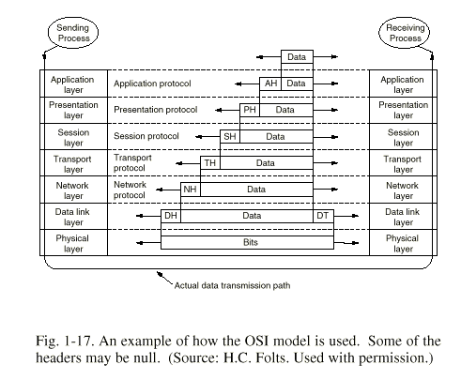

AH = APPLICATION HEADER

Presentation layer is not aware of which portion of the data given to it is actually "AH".
OSI vs TCP/IP
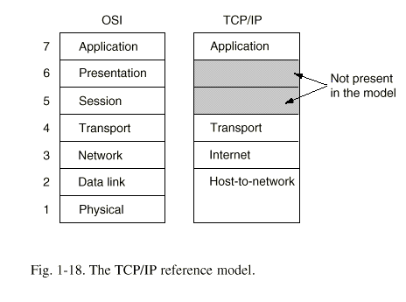

Why TCP/IP ? → DOD (Department of Defense) wanted the transmission to remain intact as long as the source & destination machines were working even if some of the intermediate machines / lines were down.

- Internet Layer: Connectionless internetwork layer (packet switched)
→ Sends packets to network and they travel independently to destination.
- The internet layer defines an official packet format & protocol called "IP"
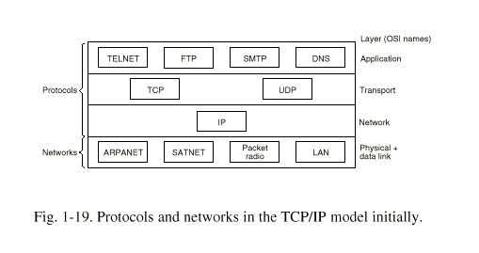
- Internet layer has to deliver "IP" packets where they are supposed to go
- Internet layer is very similar in functionality to the OSI network layer

- Transport Layer: Allows source & destination to carry on a conversation
→ Two End-to-End protocols defined:

- TCP → Reliable connection oriented protocol that allows a byte stream to be delivered w/o errors -- to any machine on the internet. TCP fragments incoming byte stream into discrete messages and passes them to internet layer.

- UDP (User Datagram Protocol)
- Unreliable connectionless protocol used for applications that do not want TCP's sequencing or flow control and wish to provide their own.
- Also used for one-shot client-server type request-reply queries in which prompt delivery is more important than accuracy, such as transmitting speech or video stream.

- Application Layer: Contains all the high level protocols
- Telnet
- FTP
- SMTP (E-Mail)
- DNS (Mapping of host names onto their network address)

- Host-to-Network Layer:
The host has to connect to network using same protocol so it can send IP packets over it.

